ALTER

description

alter command can be used with add new columns(descp)

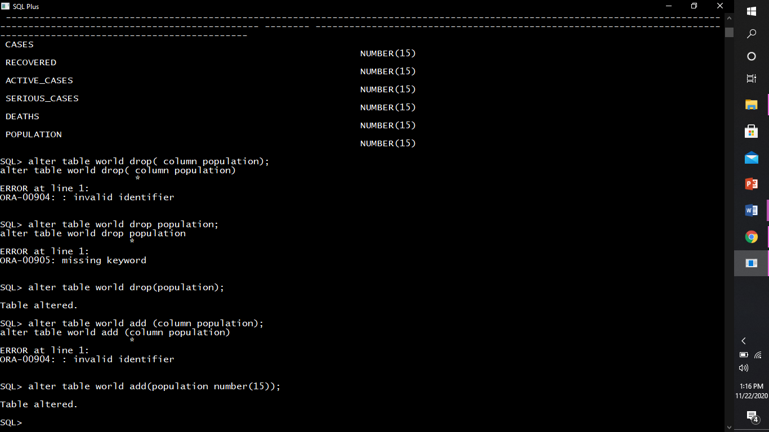

it can also be used to modify an existing column.

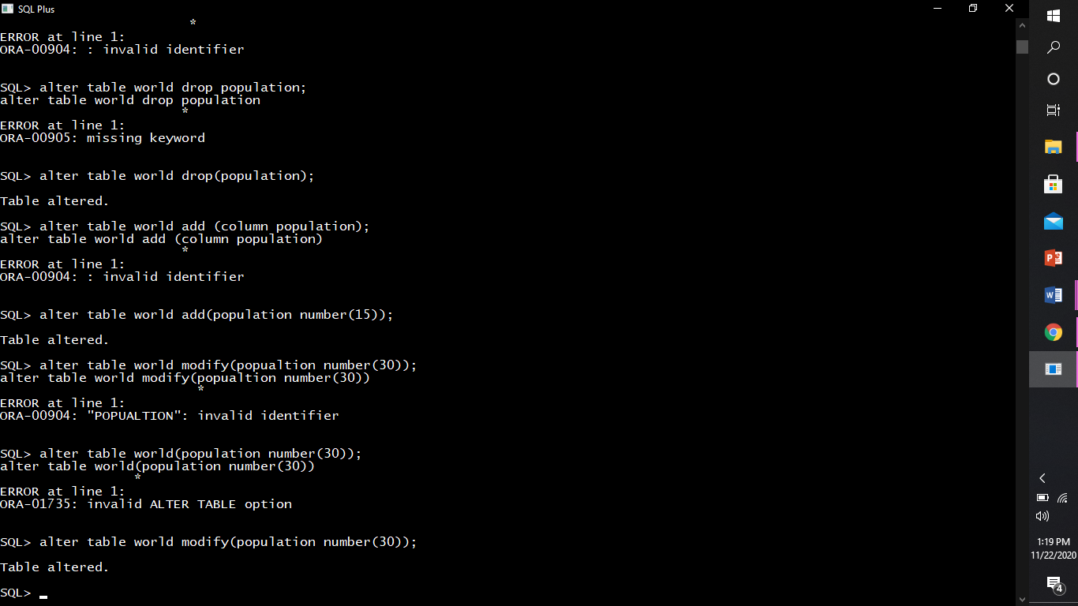

rename a column.

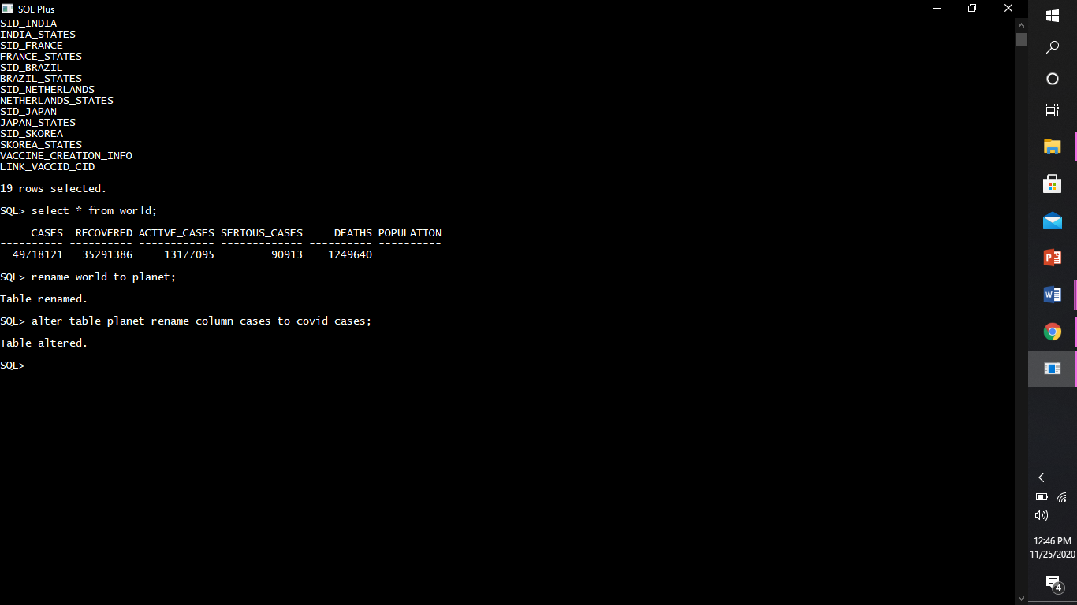

or drop columns.

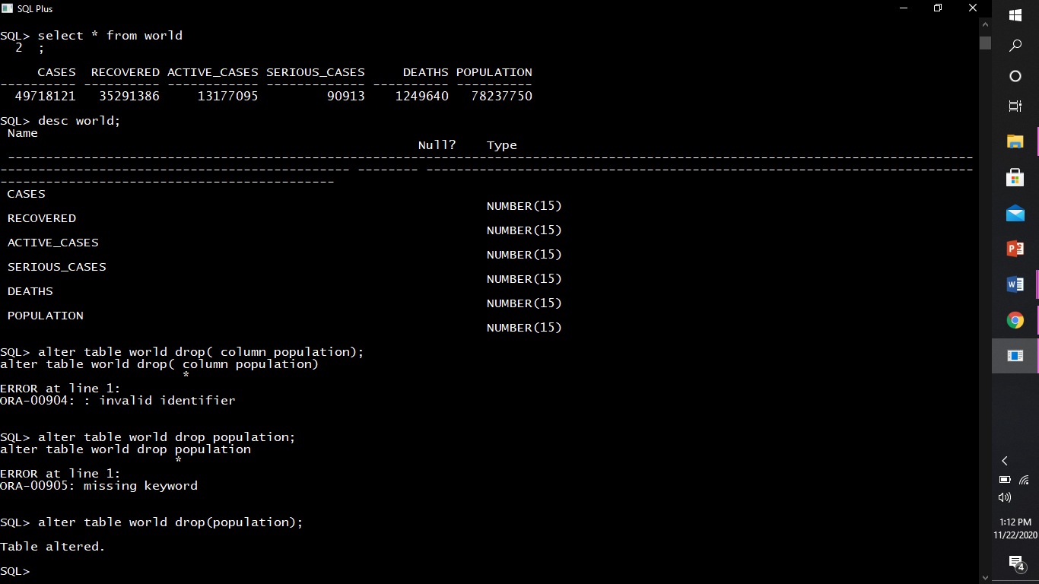

It can also be used to add constraint.

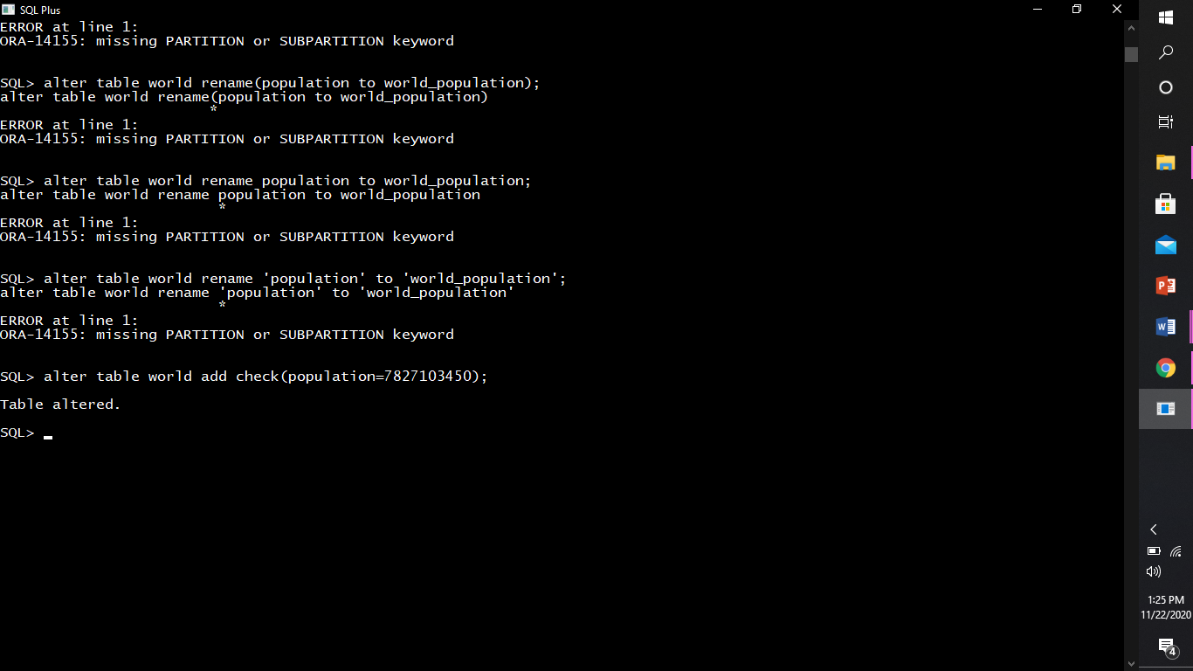

DROP(desp)

It is to drop a whole table

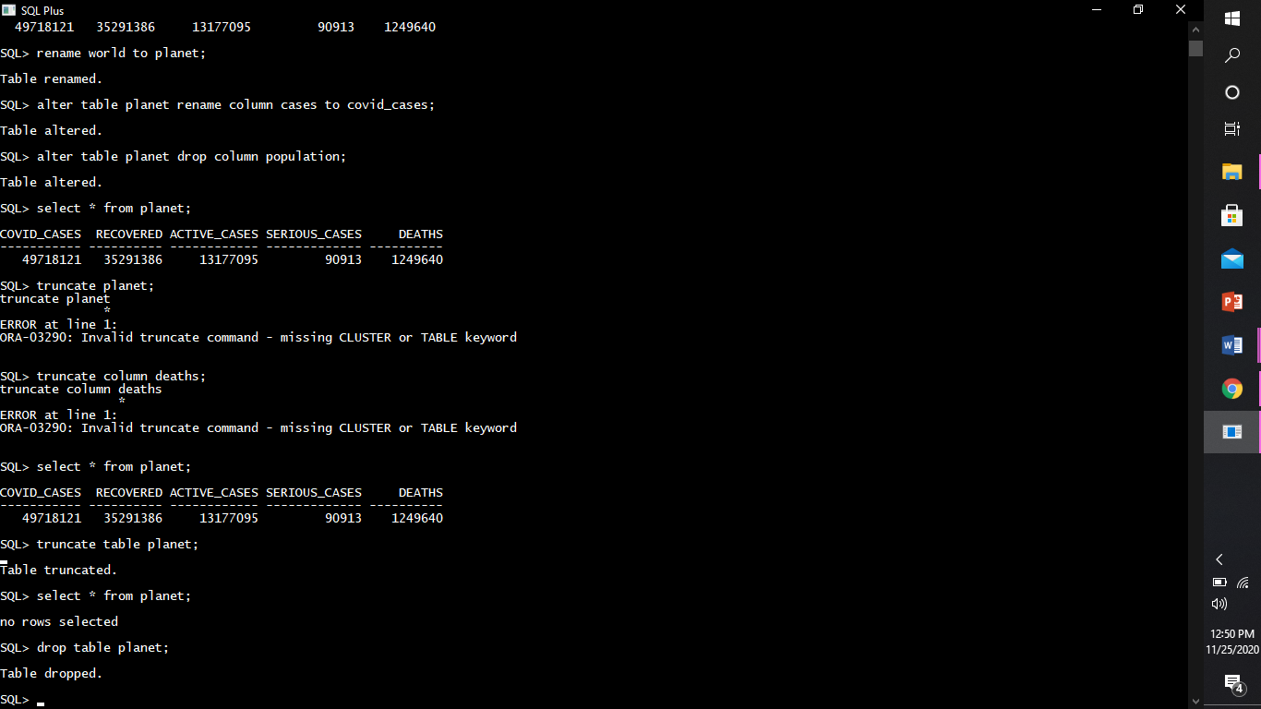

It can also be used to drop any specific column.



Truncate (desc)

Used to empty all the data from the table

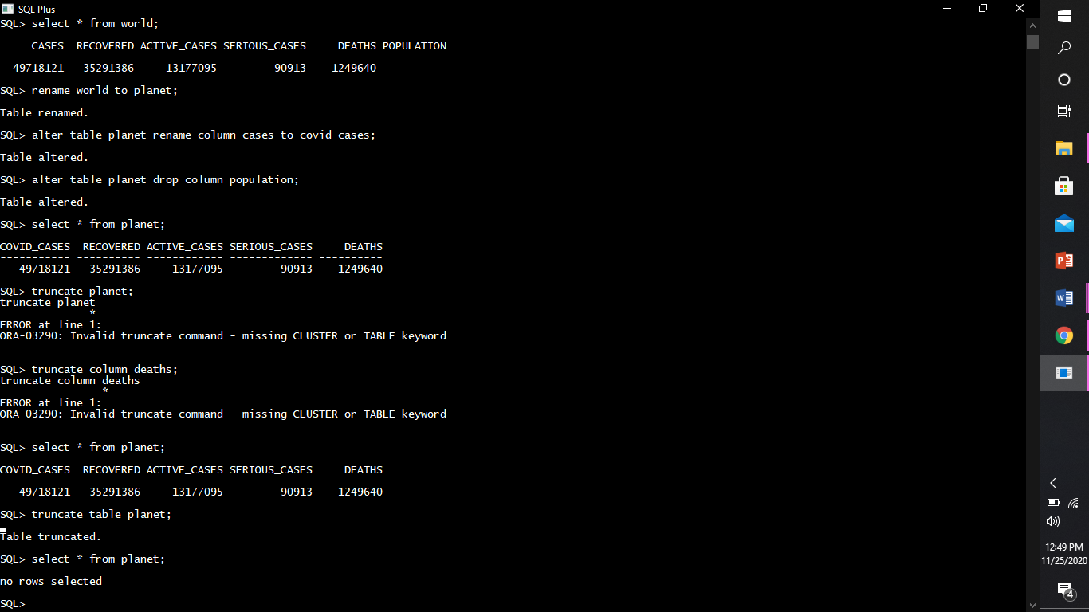

Desc(descp)

Used to determine schema of any table

Rename

Can rename a table

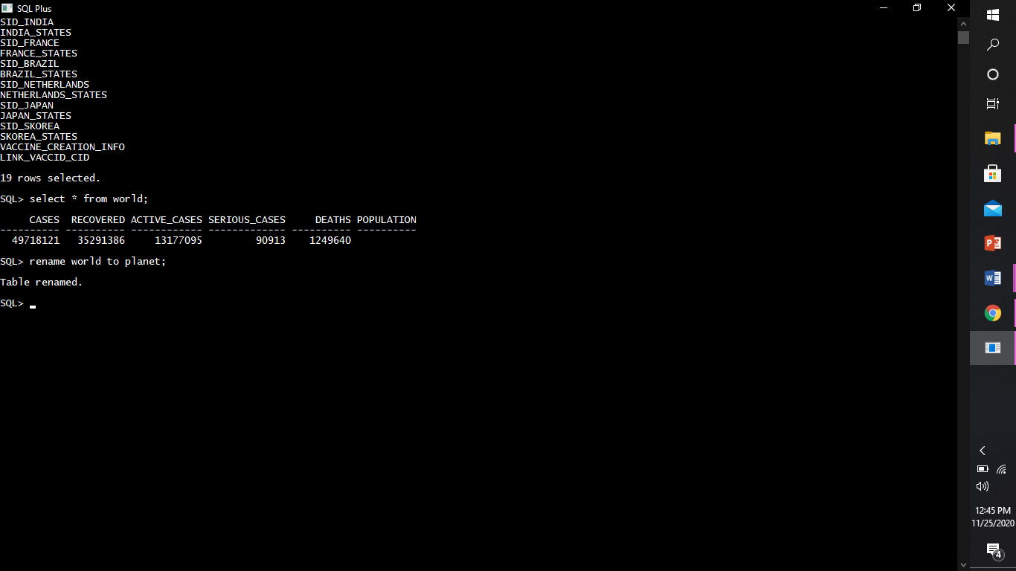

Or any specific column inside the table

